**Task 6 - Manual Testing (Project Management tool JIRA)**

Task 1: Create 5 Epics in JIRA

Epic 1:User Authentication and Access Control

Epic 2:Account Management

Epic 3:Funds Transfer

Epic 4:Transaction History

Epic 5:Payments

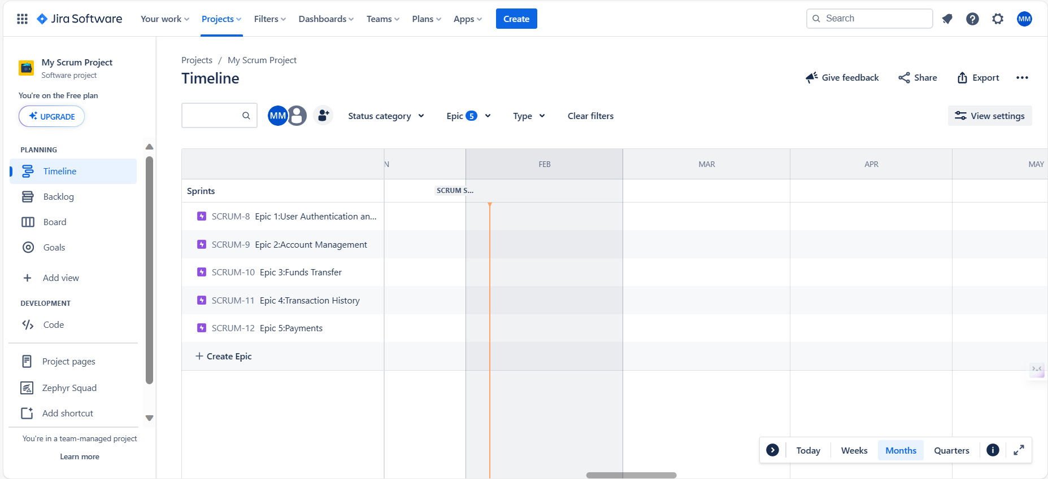

Task 2: Create User Stories for Each Epic

* Within each Epic, create user stories that represent features or functionalities.

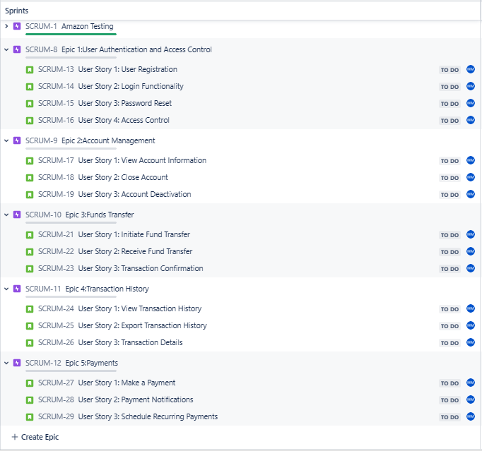

Epic 1:User Authentication and Access Control

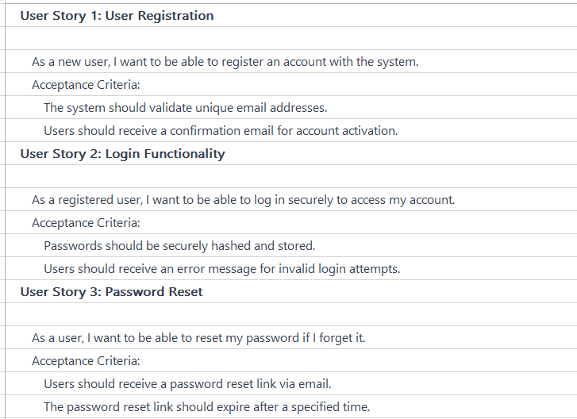

Epic 2:Account Management

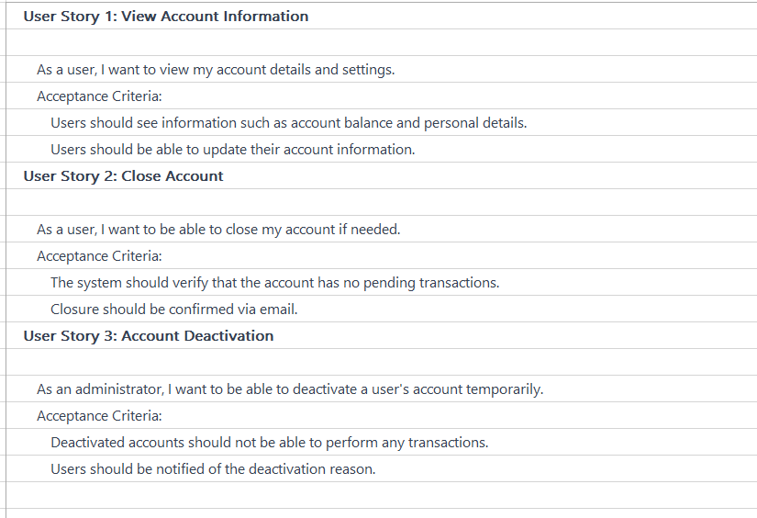

| Epic 3:Funds Transfer |
| --- |

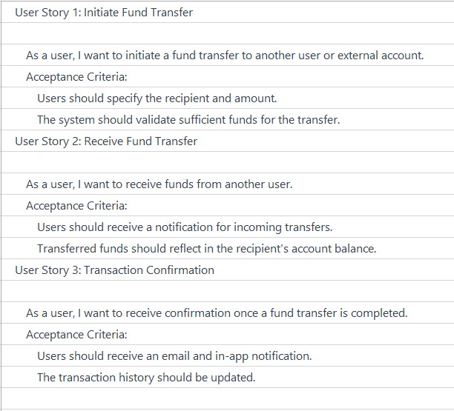

Epic 4:Transaction History

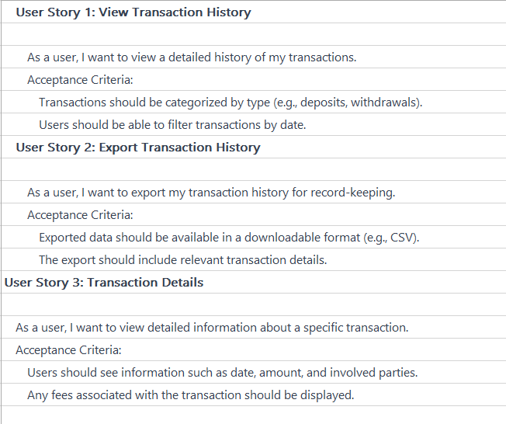

| Epic 5:Payments |
| --- |

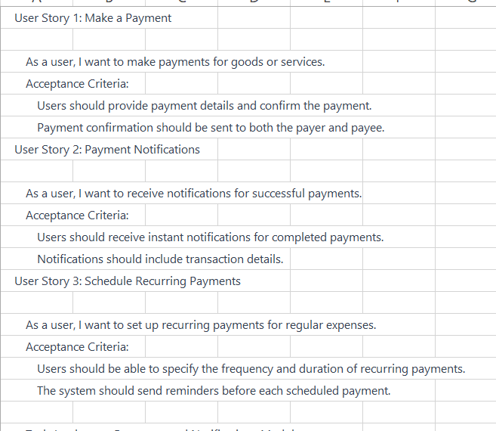

Task 3: Create Backlog Tasks Based on User Stories

* Create test cases associated to user stories and add them into it
* Upload the test scenarios using bulk option in to the zephyr squad and classify it to the respective epic folders

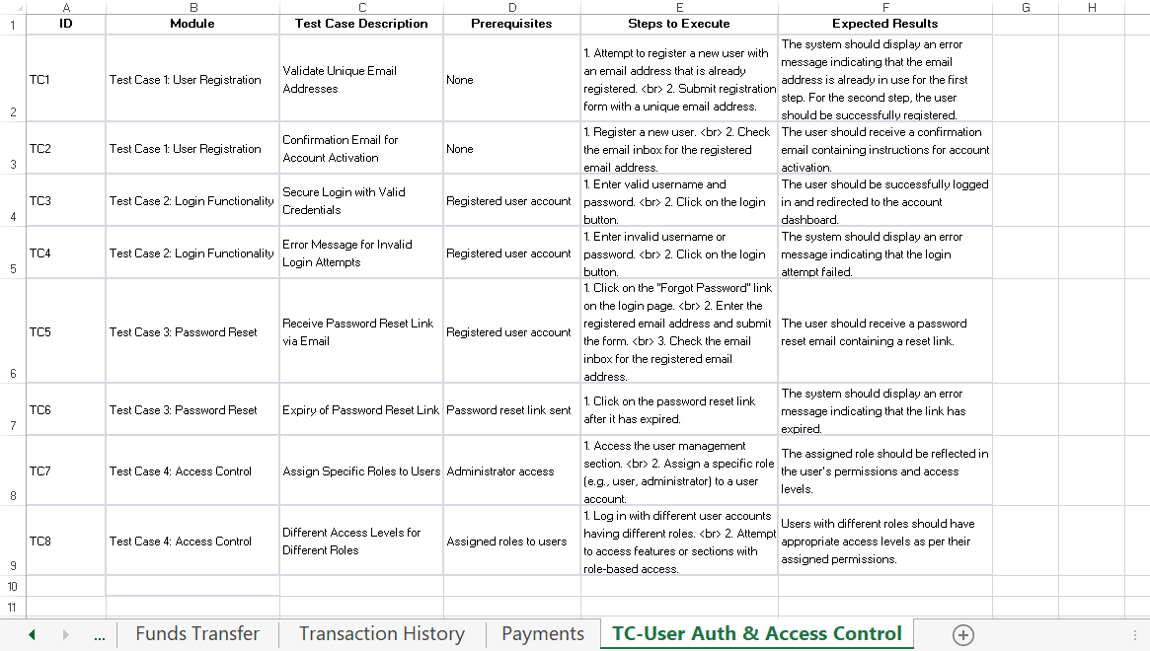

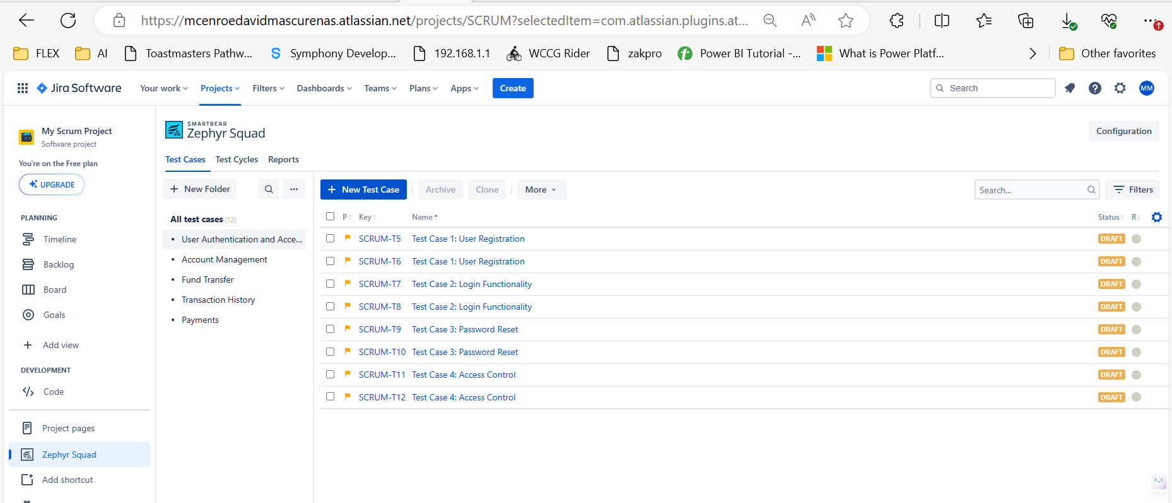

* Add the test cases to the respective user stories as follows

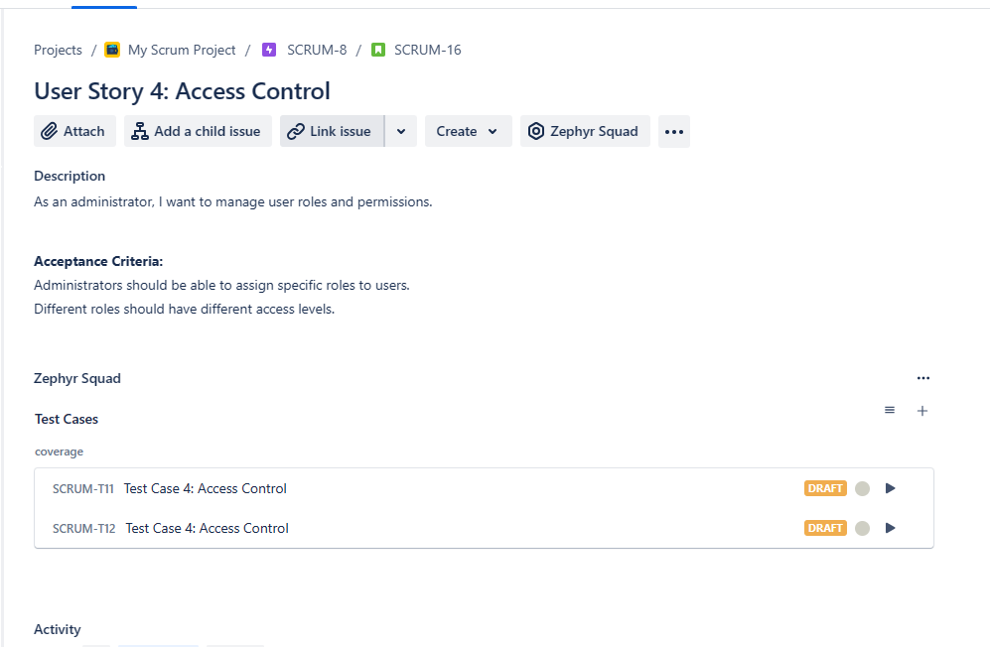

* Add existing Test case into test cycle

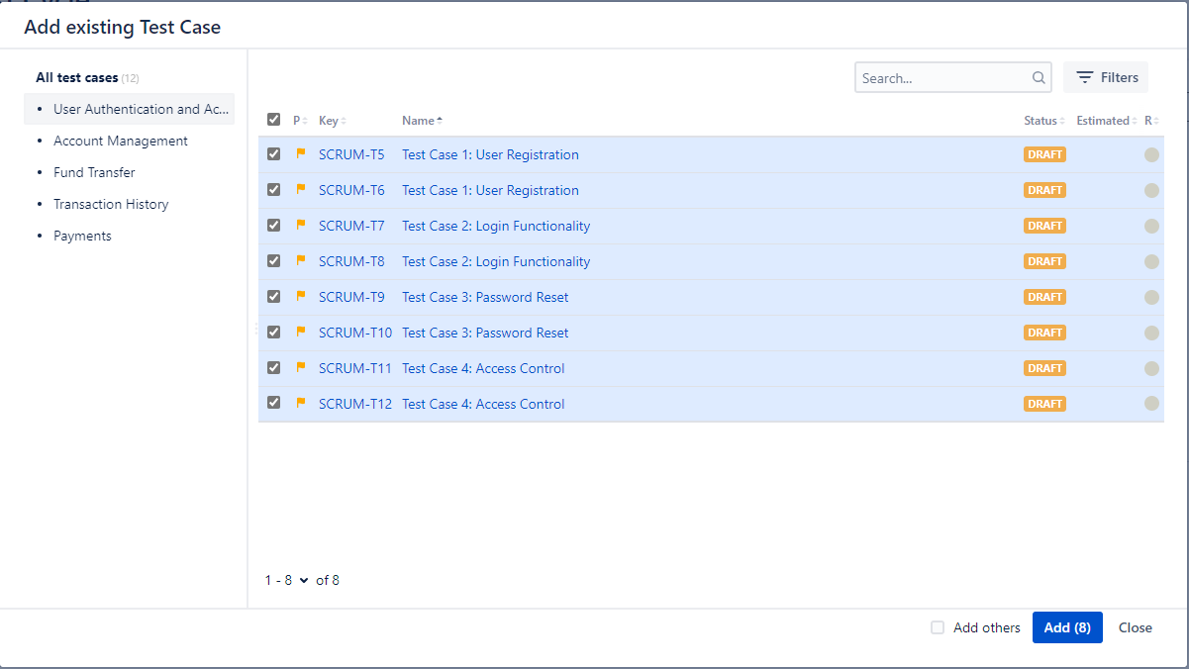

* Validate the test case. If it is passed then its ok, if it fails create a bug.

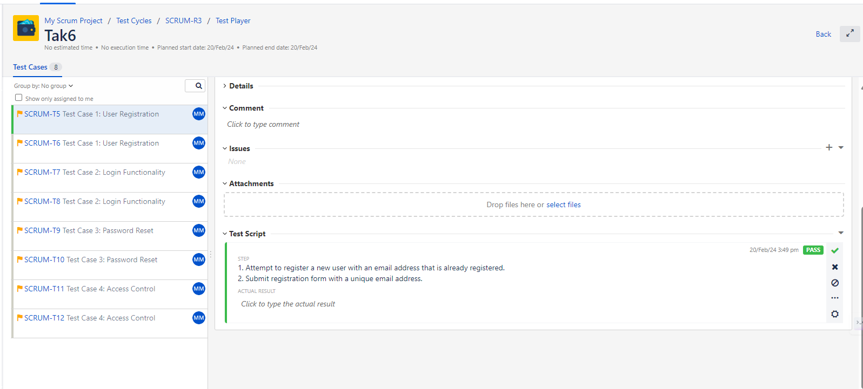

* For each test case, it will show the status as follows.

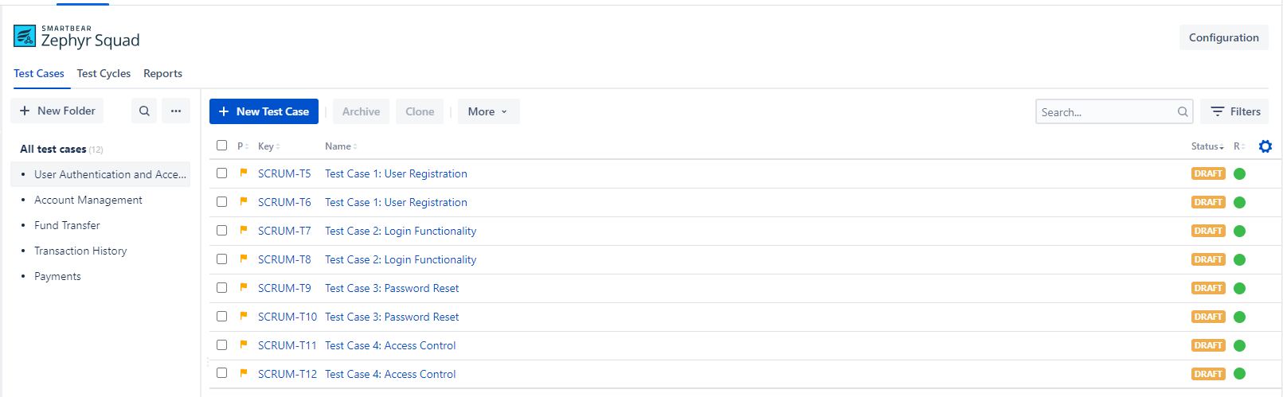

* For each test cycle, it will be getting displayed with progress status.

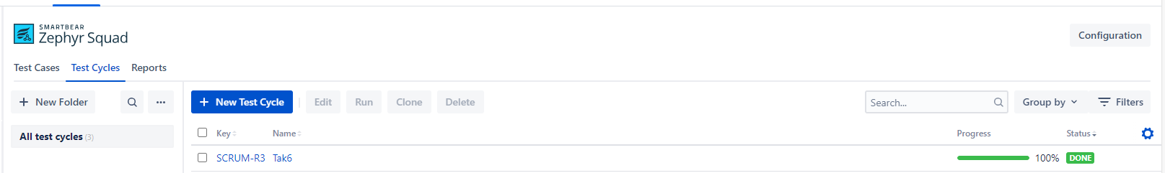

* For each user story, create detailed tasks in the backlog.

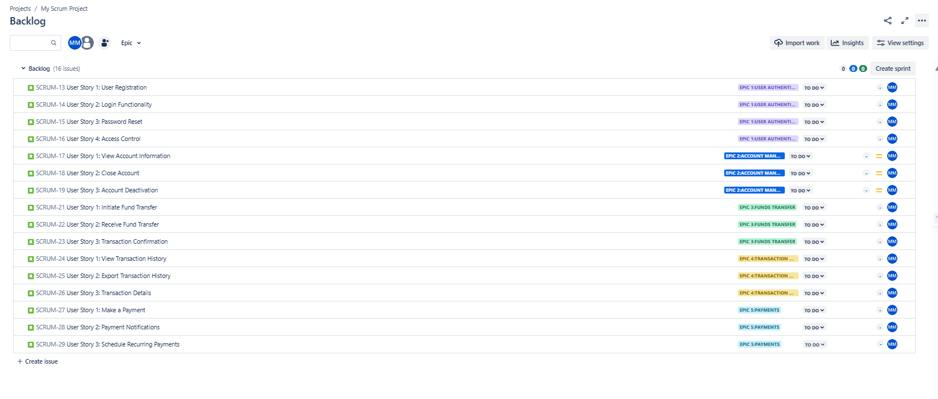

Task 4: Plan Sprints in JIRA

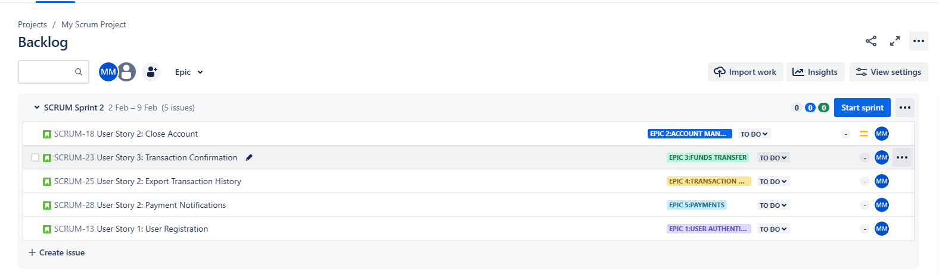

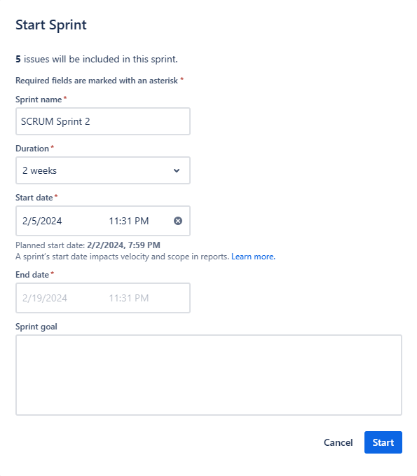

Task 5: Execute Tasks in Sprints

Update task status as "In Progress" and eventually "Done."

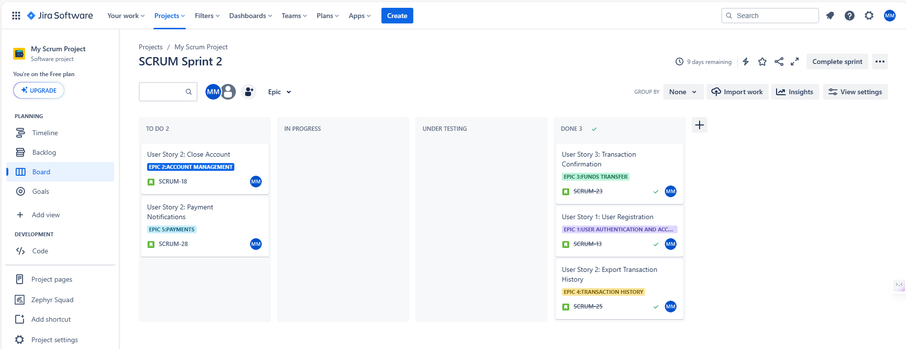

#### 

#### Task 6: Review Sprint Progress in JIRA

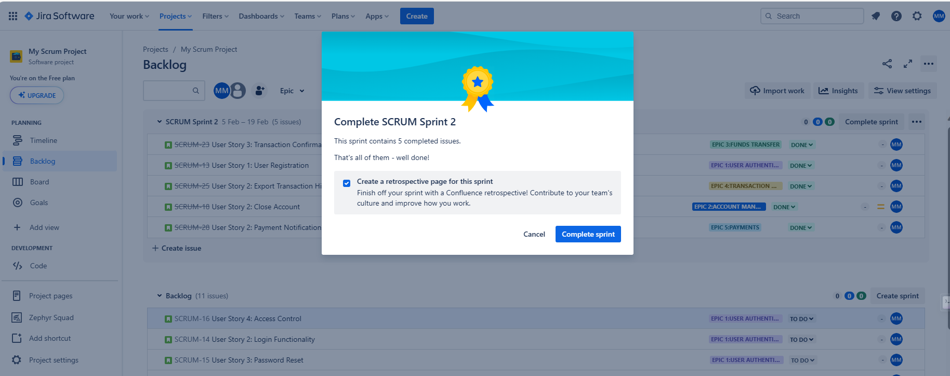

#### Task 7: Daily Scrum Meetings

Daily Scrum, also known as the Daily Standup, typically lasts for 15 minutes.

3 Main questions for each one of the members in the daily meeting as follows:

What did you do yesterday?

What will you do today?

Are there any impediments or blockers?

Task 8: Conduct Retrospectives in JIRA

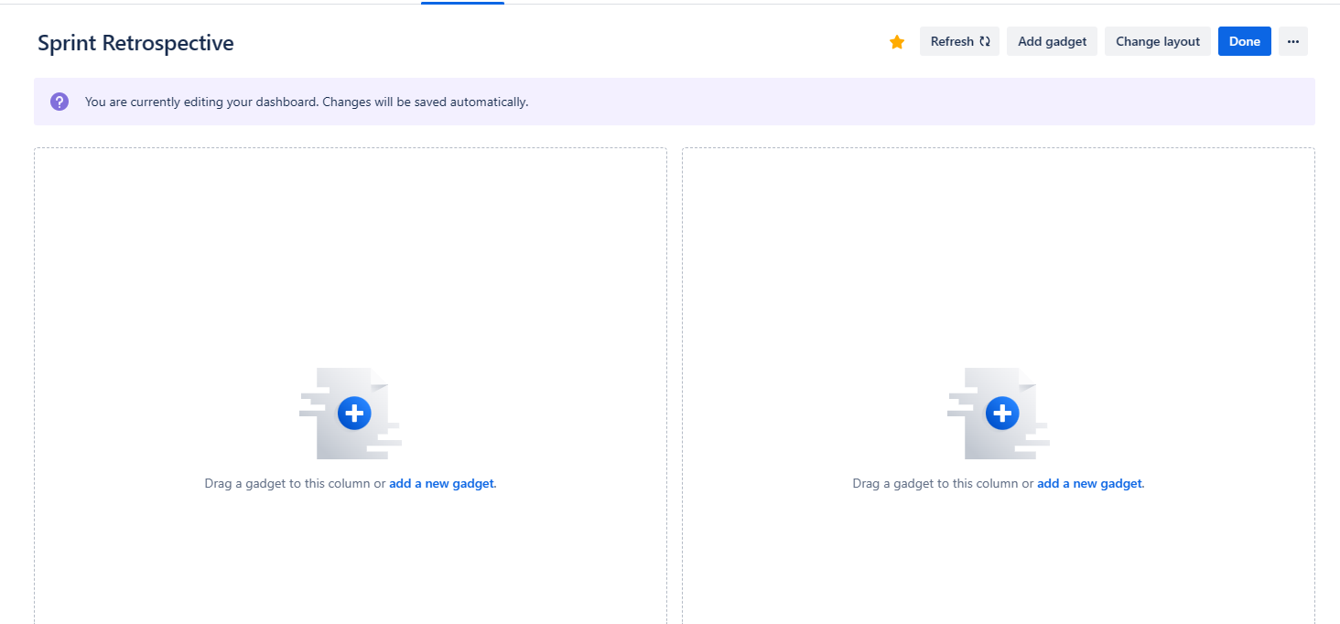

**Note :** JIRA dashboard itself we can create sprint retrospective. Limited access in the free version

Sprint retrospective is conducted after the sprint completion,it's a forum to discuss   
- More off

- keep doing

- Less off

Encourage open and honest communication during the retrospective. Create an action plan on the votes we received from the team members

#### Task 9: Plan Release in JIRA

* Check the list of issues in the version to see their status, assignees, and other relevant details.
* Use the version page to share details about the release with stakeholders.

Task 10: Define Roles in JIRA

**Project Managers** oversee the project as a whole. They may be responsible for planning, scheduling, and coordinating the team's work.

**Scrum Maste**r plays a role in facilitating the Scrum process and ensuring that the team adheres to Agile principles.

**Product Owner** is responsible for defining and prioritising the product backlog. They work closely with the development team to ensure that the highest-priority features are delivered.

**BA** Analyse and document current business processes, workflows, and systems to identify areas of improvement and optimization.

**Testers** focus on testing and validating issues. They may create test cases, execute tests, and provide feedback on the quality of the software.

**Developers** are responsible for working on and resolving issues within a project. They may also be involved in the creation and testing of new features.

**Tech Architects** manage projects related to architectural design, implementation, and other technical aspects of software development.